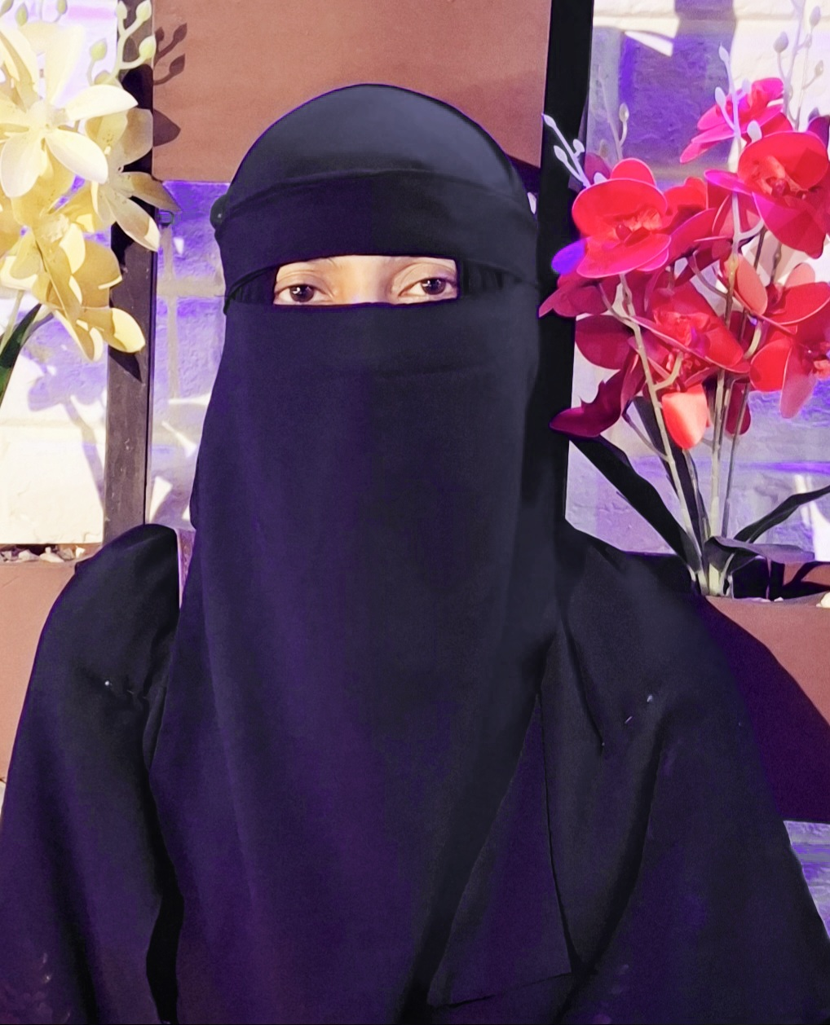 **Mst Sadeka Begum**

**Student**

**About me**

I am an dedicated undergraduate student with a strong interest in IT Support and research. I have expertise and experience in a variety of areas, such as Politics and Art Studies.

### ****Education****

**Bachelor of Social Science in Political Studies**  
Shahjalal University of Science and Technology, Sylhet, Bangladesh

### ****Experience****

**Research Assistant:** Assisted faculty and students with research activities, including literature reviews, data collection, and analysis.  
Shahjalal University of Science and Technology, Sylhet.  
From December 2023 – Present.

**Started new job at Shimantik** (01 December, 2024- present) : Contributing to community health initiatives, facilitating educational programs, and supporting operational tasks

### **Skills**

* Academic writing and editing
* Text processor
* Slide Presentation
* Excel
* Hardware maintenance of computer.
* Leadership
* Critical thinking
* Videos editing
* SPSS

### ****Activities****

* Active member of Shahjalal University Speakers’ Club, KIn( A voluntary Organization)

**Language**

* Bengali
* English

**Reach Me At**

01304285870  
 [sadekasadeka09@gmail.com](mailto:sadekasadeka09@gmail.com)

Sylhet, Bangladesh